Lowland Technology International 2021; Volume 22 (2): 01-04 International Association of Lowland Technology (IALT): ISSN 1344-9656

Research Paper

Analysis Study Proportion for Need of Labour Component on Road Development Project in Indonesia

R. Arifuddin¹, A. F. C. Putri ², and I. R. Rahim³

AR T I CL E I NF O RM AT I O N AB S T R A C T

Article history:

Received: 23 June 2021
Received in revised form: 7 July 2021
Accepted: 12 August 2021
Publish on: 6 September 2021

Keywords:

Proportion Labour
Road Construction
Infrastructure development in Indonesia continues to develop very rapidly, this development has an effect on increasing the needs of elements related to infrastructure development, one of which is manpower, need to be careful planning in the use of the number of workers according to the needs of construction activities. The research aims to model the relationship between the volume of work and the needs of workers, builders, and the number of mandors on road construction projects. The data processing on this study uses the help of Microsoft Excel programs and SPSS version 22. Data analysis techniques use simple and multiple linear regression analyses, normality tests, and correlation tests. The result of a simple regression analysis shows the influence of the number of workers, the number of foreman, and the number of successive builders of the volume of work is 15.25%, 16.31%, and 16.4%. And the results of multiple regression analysis show every improvement of the variable number of workers, the number of handyman and the number of Foreman will be followed by increased volume of work on the road construction project. Result of the results from this research can be used related government to be able to predict the number of construction workers needed to build a number of KM road.

Introduction

Infrastructure development in Indonesia continues to develop very rapidly, this development has an effect on increasing the needs of elements related to infrastructure development, one of which is Labor (Tamin, 2005). Manpower is one of the most decisive aspects of success in implementing the project, which is required to work efficiently, i.e. it can work effectively according to the number of working hours and can produce the volume of work in accordance with the job description.
Discussing the problem of human resources, this is closely related to the matter of the assessment and quantity. The problem of a limited number of workers can occur due to the execution time performed simultaneously.
For example, in a span of 2 specific time simultaneously there are two or more jobs that require skilled workers with the same skills. The contractor can increase the amount of labor but what happens is the addition of costs to the wages of workers. This is, of course, not desirable by the project owner, so there needs to be careful planning in the use of the number of workers according to the needs of construction activities.
From the background of the problem, it is necessary that a study capable of providing an overview of the influence of the proportion of labor on a construction project, which can be used as one component to predict the calculation of the right proportion for road construction, this is what the

¹ Lecturer, Department of Civil Engineering, Hasanuddin University, Makassar, r_arifuddin@yahoo.com
² Graduate Student, Department of Civil Engineering, Hasanuddin University, Makassar, aimifajirah@yahoos.ac.id
³ Lecturer, Department of Environmental Engineering, Hasanuddin University, Makassar, irwanrr@unhas.ac.id
Open Discussion Until December 2021

2
R Arifuddin et al. / Lowland Technology International 2021 ; 22 (2): 1-4

author took the research with the title of "STUDY of PROPORTION ANALYSIS FOR the NEED of LABOR COMPONENT ON ROAD DEVELOPMENT PROJECT IN INDONESIA”.

Review of The Library
  - Construction projects
Project activity can be interpreted as a temporary activity that lasts for a limited period of time, with the allocation of certain resources and intended to produce products or deliverables whose quality criteria have been outlined clearly, (the Faith of Suharto, 1999).
Construction projects have unique characteristics that are not repeated in other projects. This is due to conditions affecting the process of a construction project differently from each other. For example, natural conditions such as geographical location, rain, earthquake and soil condition are factors that also affect the uniqueness of construction project (Wulfram, 2004).

  - Road Construction
According to UU No. 38 tahun 2004 on road defining roads is a land transportation infrastructure covering all parts of the road, including complementary buildings and equipment for traffic, which is on the ground level, above ground, below ground and/or water, as well as on the surface of the water, except railway, truck Road, and Cable road.

  - Labor
According to Suharto (1995) that to organize the project, one of the resources that became the deciding factor of success is labor. Estimate the amount of manpower required, that is by convert the scope of the project from the number of hours-people to a number of jobs. Theoretically, the average need for a workforce can be calculated from the total work scope of the project expressed in hours-person or month-person (man-month) divided by the period of implementation.

Research Methods

In the project data analyzed is the road development project in Indonesia, where the work items consist of public works, drainage work, earthwork, grain pavement, asphalt work, and structural works. So it can be said that the data of road building projects used in this research is a similar project data name from the similarity of the work item.
Research conducted in Makassar City, South Sulawesi by analyzing Contract Documents of 10 road construction projects from the Ministry of Public Housing and people's housing to obtain a proportion of the number of workers in road construction projects.
Based on the library studies that have been done before variables are tied and the free variables used in this research can be seen in the following table

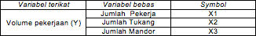
Table 1. Variable Research Here are the stages in the study:
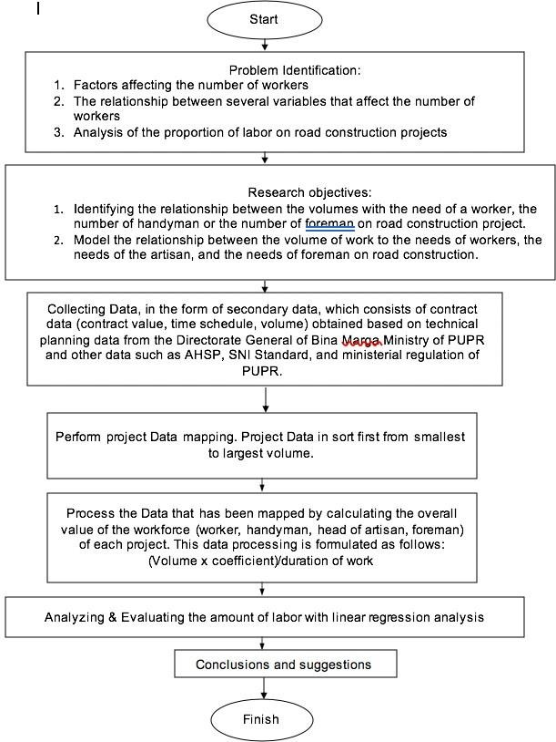
Fig 1. Research flows

Results and Discussion
  - Research Data
Data collection is done by analyzing the number of workers in the implementation of the road construction projects in particular on the number of field workers, the data on this road project obtained from the Directorate General of the PUPR Ministry. Data collection is conducted by analyzing several documents including,

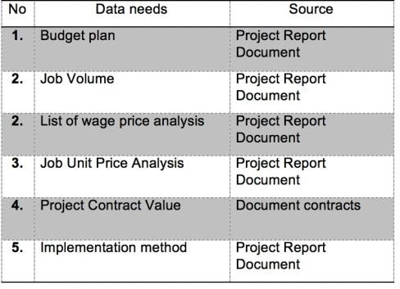
Table 2. Data and Sourcing needs

R Arifuddin et al. / Lowland Technology International 2021 ; 22 (2): 1-4

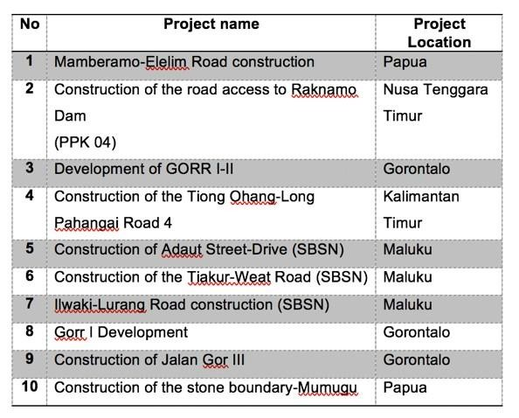
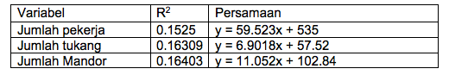
The sample of the project used as a data source in this research is the following road development project data in Indonesia,
Table 5. Effect of variables on Volume of work According to table 5, the analysis results show that
donations influence the number of workers to the job volume is 15.25%. And successively for the number of handyman and the number of Foreman is, 16.31% and 16.4%.

  - Results

Table 3. Project Location

The relationship between the work volume and the needs of workers, builders, and foreman on road construction projects

Based on the analysis of the road development project that has been analyzed, from the Excel output it

The relationship between the job volume and the
needs of workers, artisan or foreman on road construction projects
In this analysis field workers are grouped into three groups: worker, artisan, and Mandor. Before knowing the relationship between the volume of work and the three aspects of labor first analyzing the proportion of the needs of the number of workers in road development projects, analysis is done in a descriptive way to know the magnitude of proportion for each workforce on each project sample. Then based on the worker variables (X1), the artisan (X2), and the foreman (X3) performed a linear regression analysis to find out the model of use based on the job volume (Y)
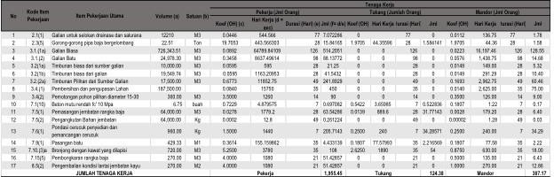
Table 4. Example of calculation table of employment of Mamberamo Road development project – Elim III (P1)

Analysis results influence of variable relationship free to bound variables

The Data of independent variables and the dependent variables that have been outlined are included as inputs that further undergo the process of analysis of the influence of variables so that they can know the strength of the relationship between each variable, which can be seen in the table below,
appears that with a confidence level of 95%, the regression coefficient for each independent the is the number of workers (X1), the number of builders (X2), and the number of foreman (X3) on the Volume of work (Y) is as follows,
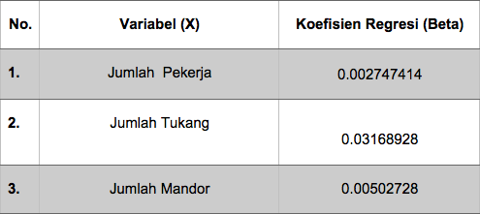
Table 6. Multiple regression analysis test results

According to the table above, can be obtained model of linear regression equation as follows:

Y = β1X1 + β2X2 + β3X3
Y = 0.002747414 X1 + 0.03168928 X2 + 0.00502728 X3
Variable regression coefficient of worker number (X1) of 0.002747414 means that if the number of workers is increased by 1 unit, the volume of work has also increased by 0.002747414 units. Coefficient of positive value means there is a direct connection between the number of workers and the volume of work. This indicates that any increase in the number of workers, will be followed by increased volume of work.
Variable regression coefficient of the artisan number (X2) of 0.03168928 means that if the number of the artisan increased by 1 unit, the volume of work also increased by 0.03168928 units. Coefficient of positive value means there is a direct relationship between the number of handyman and the volume of work. This suggests that any increase in the number of handyman, will be followed by increased volume of work.

4
R Arifuddin et al. / Lowland Technology International 2021 ; 22 (2): 1-4

The variable regression coefficient of the amount of 0.00502728 foreman (X3) means that when the number of mandors is increased by 1 unit, the volume of work has also increased by 0.00502728 units. Coefficient of positive value means there is a direct connection between the number of workers and the volume of work. This indicates that any increase in the number of workers, will be followed by increased volume of work.

Conclusions and suggestions

  - Conclusions

Based on the results of data analysis and the discussion obtained the following conclusions:

- Results of analysis with simple regression analysis on each road construction project, resulting in the value of R square that can explain the influence of the number of workers, the number of the worker or the amount of foreman to the volume Where:
  - The influence of the number of workers to work volume 15.25%
  - Influence of the number of handyman to the volume of work 16.31%
  - Influence of the number of mandors on the volume of work 16.4%

- Analysis results with multiple regression analysis where,
Y = Job Volume
X1 = number of workers X2 = number of handyman X3 = number of mandors
Produced the following mathematical models,

Y = 0.002747414 X1 + 0.03168928 X2 + 0.00502728 X3
From the mathematical models above can be concluded that, if the number of workers, the number of the artisan, and the number of the mandor is increased by 1 unit, then the volume of work will also increase the amount of the coefficient owned by each variable based on the result of the above modelling.

References

Dipohusodo, Istimawan. 1995. Manajemen Proyek & Konstruksi Jilid 1. Yogyakarta : Badan Penerbit Kanisius.

Ervianto, Wulfram I. Manajemen proyek konstruksi.
Yogyakarta. Andi Yogyakarta. 2004

Herizal, 2004, Penerpan Cost Significant Model sebagai Dasar Estimasi Biaya Proyek Gedung-gedung Pemerintah, UII, 2004

Hermiaty, Dessy, Pemodelan dan Analisis Proporsi Upah Tenaga Kerja pada Proyek Konstruksi, Tesis Magister Manajemen Konstruksi, UII, 2007

Meredith, G.G. 2000. Kewirausahaan: Teori dan Praktik.
Jakarta: Pustaka Binaman Presindo

Mulya. 2012. Kebutuhan Kompetensi pada Perusahaan Jasa Konstruksi Bidang Pelaksanaan Bangunan di Malang Raya. Tesis tidak diterbitkan. Malang: Pascarjana Universitas Negeri Malang.

Ofyar Z. Tamin, Perencanaan dan Pemodelan Transportasi, ITB 2003.
Soeharto, Iman. 1995. Manajemen Proyek: Dari Konseptual Sampai Operasional. Jakarta: Erlangga.

Silvia Sukirman, Dasar-dasar Perencanaan Geometrik Jalan, Nova-Bandung 1999.

Trijono, Lambang.2007.Pembangunan Sebagai Perdamaian, Yayasan Obor Indonesia :Jakarta.

Undang-undang Republik Indonesia No 18 Tahun 1999, Tentang Jasa Konstruksi. Vaza, Herry, Sistem dan Teknologi Konstruksi, Pusat Penilaian Mutu Konstruksi,

BAPEKIN, Kimpraswil

