The Comparison of Fractional Derivative Model and
Classical Spring-Dashpot Model in the Identification of
Viscoelastic Characteristics of a Rubber Material

Daisuke Narita^{a,}*, Yoshiki Ohta^{b}

ªHokkaido University of Science, Junior College. Email: narita@hus.ac.jp
^{b}Hokkaido University of Science, Faculty of Engineering. Email: ohta@hus.ac.jp

Abstract
In the design of viscoelastic materials used in rubber products, not theoretical approaches but experimental approaches have been usually employed. This is due to the difficulties in mathematical procedures of the dynamic material characteristics such as the dependencies of strain amplitude, frequency and/or environmental temperature in deformation. In mathematical approach there are two kinds of analytical models for a complex module of the material, which are a fractional derivative model and a spring-dashpot model. However, there are few papers dealing with the study of not only the identifications of parameters for the experimental modulus actually obtained both of by using the fractional derivative model by using the spring-dashpot model and but also the discussion of the comparisons of the two models. In the present paper, the complex elastic modulus for a rubber material is obtained experimentally for a wide range of excitation frequency, and the modulus-frequency relations are derived analytically by using the two models, respectively. Finally, the applicability of the models for parameter identification are discussed from the numerical results.
Keywords: Complex module; fractional derivative model; parameter identification; spring-dashpot model; viscoelastic material

- Introduction
In the design of viscoelastic material used in rubber products such as automobile tires, not theoretical approaches but experimental approaches have been employed usually. This is due to the difficulties in mathematical procedures of the dynamic material characteristics, complex elastic module, which are the dependencies of strain amplitude, excitation frequency and/or environmental temperature in deformation.
In Jones’s handbook [1] there are two kinds of the mathematical, analytical models for complex elastic module for the materials. First one is called as a classical spring-dashpot model, and the model consists of the serial and/or parallel combinations of spring elements and dashpot elements, which represents elastic and viscous behaviors, respectively. On the other hand, another one is a fractional derivative model, and the model is assumed to be the mathematical fractional derivative of the displacement with respect to time.
In the past researches by using the fractional derivatives,
*Corresponding author. Tel.: +81-11-681-8607
Maeda, Teine
Sapporo, Hokkaido, Japan, 006-8585

Shimizu [2] elucidated the fundamental characteristics of the oscillator composed of the silicone gel and a mass, and the fractional time-derivative Voigt model of the silicone gel and the equation of motion of a single degree of freedom oscillator having the fractional derivative term was derived. Shimizu and Iijima [3] also studied the fractional differential approach to model the polymeric viscoelastic material, and the fractional differential equation for a single degree of freedom viscoelastic oscillator was solved, and the characteristics of the oscillatory system with the material were discussed. Nasuno et al. [4] proposed the appropriate models to describe the behavior of the fractional derivative viscoelastic body by considering nonlinear statical and dynamical models in order to understand the behavior of higher damping capacity by pre-stress due to pre-displacement. Fukunaga and Shimizu [5] proposed two type of models for describing nonlinear fractional derivative dynamical behavior of viscoelastic materials subject to impulse forced. Narita et al. [6] studied the identification of parameters of the fractional derivative model for the experimental results of complex elastic modulus of a viscoelastic material, and the applicability of the model for constructing the modulus-frequency relations of the material was discussed. However, there are few papers dealing with the comparisons of the fractional derivative model and the classical spring-dashpot model in identification for the complex elastic modulus (Young’s modulus and loss factor) of a viscoelastic material such as a rubber material.
This paper studies the applicability of the two models in constructing the curves between the complex elastic modulus and excitation frequency in vibration. For this purpose, the vibration tests for the material are carried out, and the master curve, which indicates the dynamic characteristics of the material for wider range of frequency, is obtained numerically by applying the W.L.F. equation. The fractional derivative model and the classical spring-dashpot model are then assumed for the material, and the parameters of the two models are identified for the master curve. In numerical identification the Solver Procedure of the Microsoft EXCEL is employed in the present study. Finally, the applicability of the fractional derivative models is discussed by comparing the numerical results.
- Dynamic Characteristics of a Rubber Material
Figure 1 shows the general dynamic characteristics of a viscoelastic material to an environmental temperature, which are Young’s modulus and loss factor of a viscoelastic material. As shown in the figure, the property of the characteristics is divided into 4 regions, which are a glass region, a transition region, a rubber-like region and a flow region. There are the similar tendencies in the general dynamic characteristics of the material with respect to the excitation frequency, and time-temperature superposition principles for a viscoelastic material is also well-known.
According to the time-temperature superposition principle for the transition region of the material the superposition parameter α_{T} is given by the W.L.F. equation:

(1)

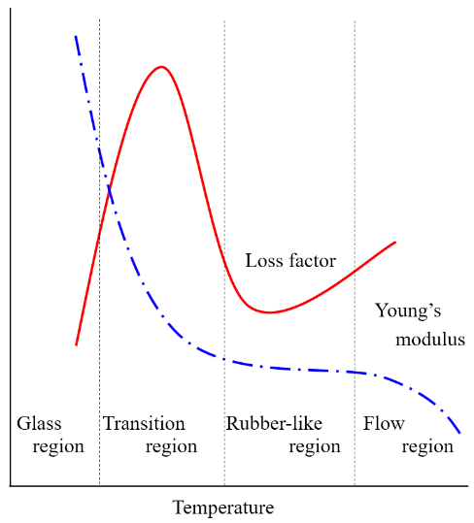

Figure 1. General dynamic characteristics of viscoelastic materials
where T is environmental temperature, T_{o} is a reference temperature chosen to construct the compliance master curve and C₁, C₂ are empirical constants adjusted to fit the values of the superposition parameter α_{T}.
By applying the W.L.F. equation to the experimental results for the frequency range where a vibration test can be actually carried out, the dynamic characteristics for the wider frequency range is numerically estimated.
In the present study Young’s modulus and loss factor of a natural rubber sheet (NR0505, AS ONE) in stretching vibration are obtained experimentally by using the experimental device shown in Fig. 2 (Dynamic Mechanical Analyzer DMA7100, HITACHI). In experiment the complex module is measured at the environmental temperatures from 183K to 373K by oscillating at frequency of 0.1, 0.2, 0.5, 1, 2, 5, 10, 20 Hz, respectively. The master curve is also construed numerically from the experimental results by using the optional software, DMA Master Curve Analysis Option.
Figure 3 shows storage modulus (real part of complex modulus) (E’), loss modulus (imaginary part of complex modulus) (E”) and loss tangent (tan D) obtained experimentally with strain amplitude 20μm. The complex moduli obtained experimentally are almost same even by oscillating with the strain amplitude of 5, 10 and 20μm, respectively.
Figure 4 shows the master curve obtained by using the optional software from the experimental results in Fig.3, whereas a glass-transition temperature and a reference temperature are set to be -70℃ and 23℃, respectively. The empirical constants are also given by C₁ = 27.0 and C₂ = 52.0.
- Identification Models for Complex Module
  - Fractional derivative model
The simplest fractional derivative formulation for a stress-strain relation can be assumed to be the form:

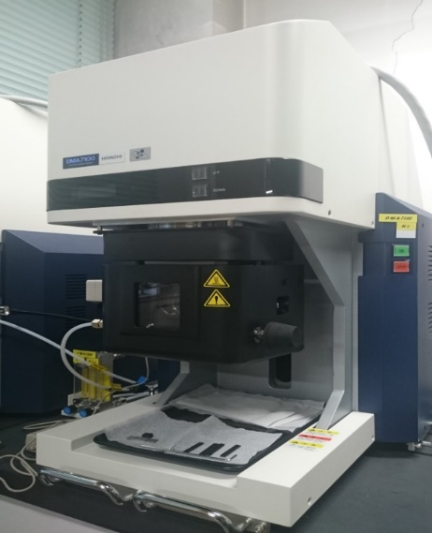

Figure 2. Experimental equipment used in vibration test (DMA7100, HITACHI)
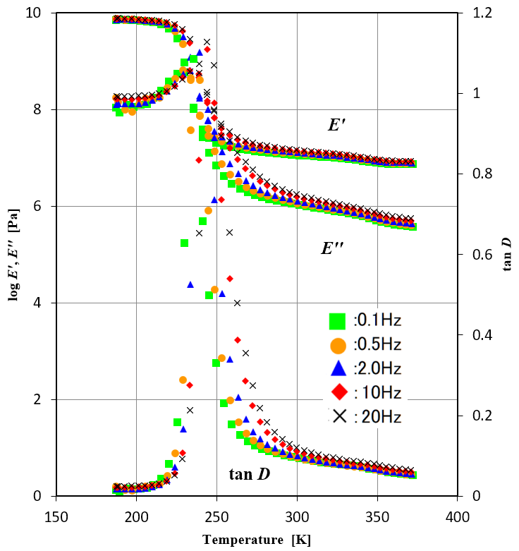

Figure 3. Experimental results of complex module from vibration test

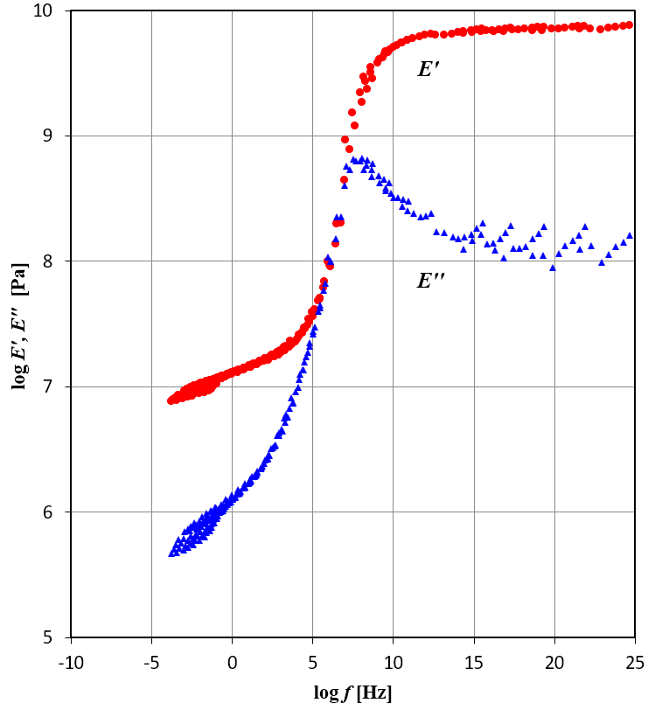

Figure 4. Master curve obtained numerically from experimental result

(2)

where a, b, c and β are unknown parameters to be chosen by parameter identification to the master curve. The above relation can be reduced for a steady vibration by using a circular frequency ω into the equation:

(3)

And a complex module E₁* is expressed by this equation :

(4)

where the term ω^{p} is added here for correction [1]. In the present study the parameter identification for the master curve is conducted by using the parallel combination of N-set of the equation (4).
  - Classical spring-dashpot model
In the classical spring-dashpot model a spring element and a dashpot element are combined to represent the dynamic characteristics of a viscoelastic material. Figure 5 shows the standard combination model of a simple Maxwell-type model and a simple Voigt-type model, where k_{i} and c_{i} are a spring constant and a damping coefficient, respectively.
For the model a complex module E₂* is given by this equation :

(5)

- Parameter identification for complex module
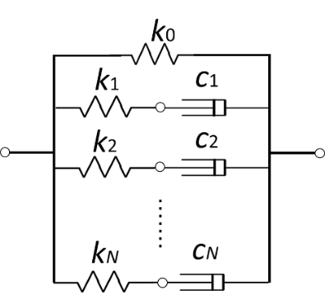
In the present identification the master curve from 1 Hz to 10⁵ Hz is picked up because the structural design and analysis of the material is considered in our research group.

Figure 5. Standard spring-dashpot model
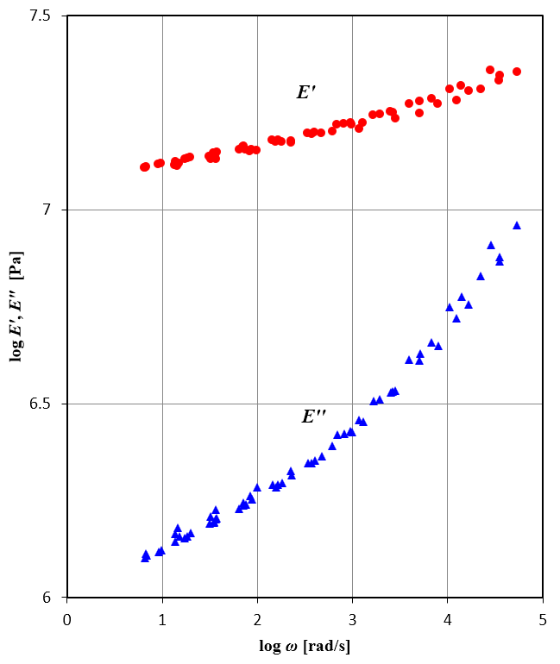

Figure 6. Master curve to be identified for the frequency of 10⁰～10⁵Hz
And the complex module is identified analytically by using not only fractional derivative models but also a standard spring-dashpot models. Figure 6 shows the master curve picked up from in Fig. 4.
In identification, the parameters of the two models are obtained numerically respectively by minimizing the evaluation function F :

(6)

where E’_{i} and E”_{i} are estimated numerically from the equation (4) or (5), E’_{exp} and E”_{exp} are the experimental valued on the master curve and E’_{ave} and E”_{ave} are averaged values of experimental results, respectively, and the iteration calculations are carried out by using the Solver Procedure of the Microsoft EXCEL in the present study.
Figure 7 shows evaluation function F minimized by using the fractional derivative model with different N-set of models. As shown in the figure, the evaluation function can be converged by taking just 2 sets of models (N = 2). Figure 8 shows the function values by the standard spring-dashpot model with different N-set of models. In this case, more than 5-sets or 6-sets of models is required to the convergence of the estimation function, and the converged function value is also relatively higher than the one in Fig. 7. Tables 1 and 2 give the converged function values and identified parameters numerically in the fractional derivative model and the

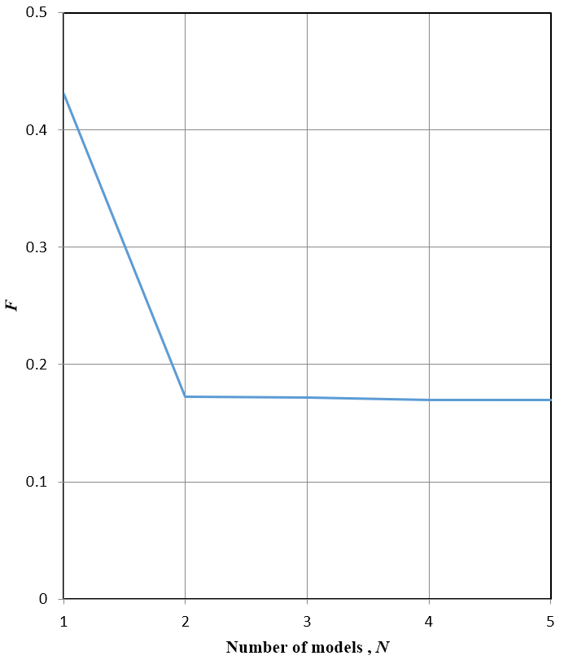

Figure 7. Evaluation function F with different set N of fractional derivative models
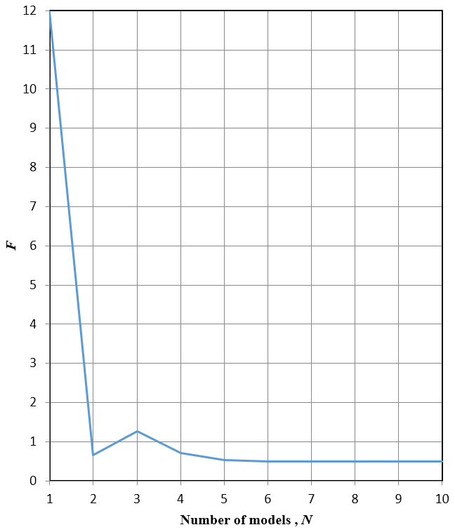

Figure 8. Evaluation function F with different set N of standard spring-dashpot models

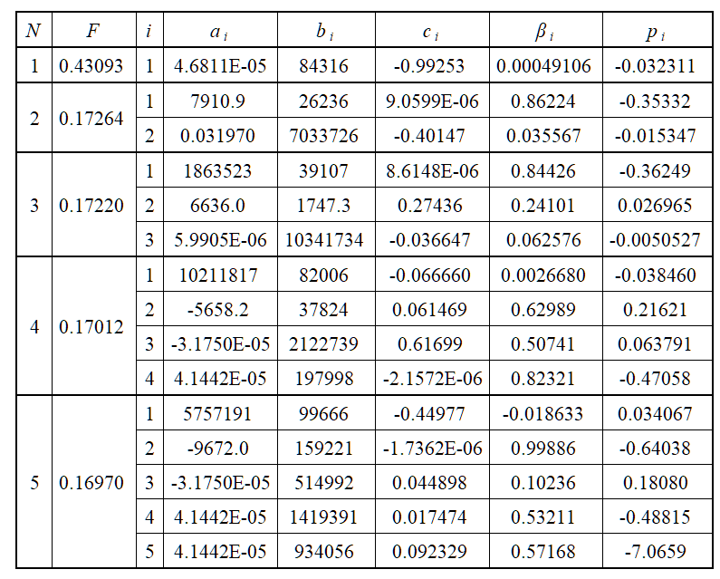
Table 1. Identified parameters of fractional derivative models (N = 1～5)

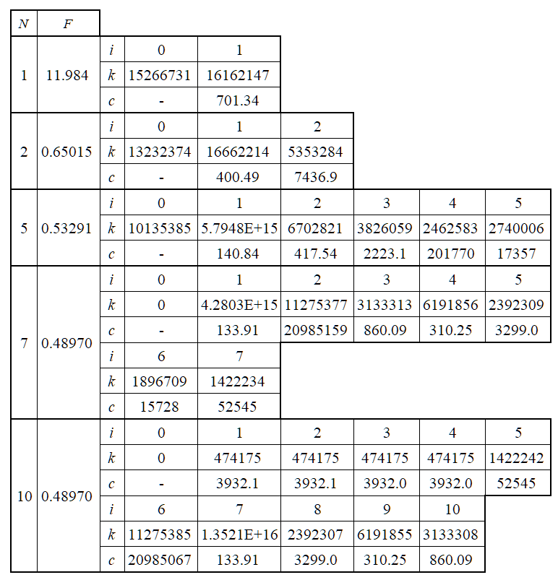
Table 2. Identified parameters of standard spring-dashpot models (N = 1～5)

standard spring-dashpot model, respectively.
Figure 9 shows the comparison of the complex modulus of E’ and E” identified numerically by assuming 1 set of the fractional derivative model (N = 1) (shown by solid lines) and the master curve data (shown by × mark). Figure 10, 11, 12 and 13 correspond to the comparison by assuming 2, 3, 4 and 5 set of the models, respectively. As shown in these figures, better agreement in the curve fitting can be observed as the number N of the model is increased from 1 to 5, and the curve fitting by taking more than N = 2 can be almost similarly. Therefore, the fractional model with N = 2 is enough to get better parameter identification.
Figure 14 shows the comparisons by assuming 1 set of the spring-dashpot model in contrast, and Figures 15, 16, 17 and

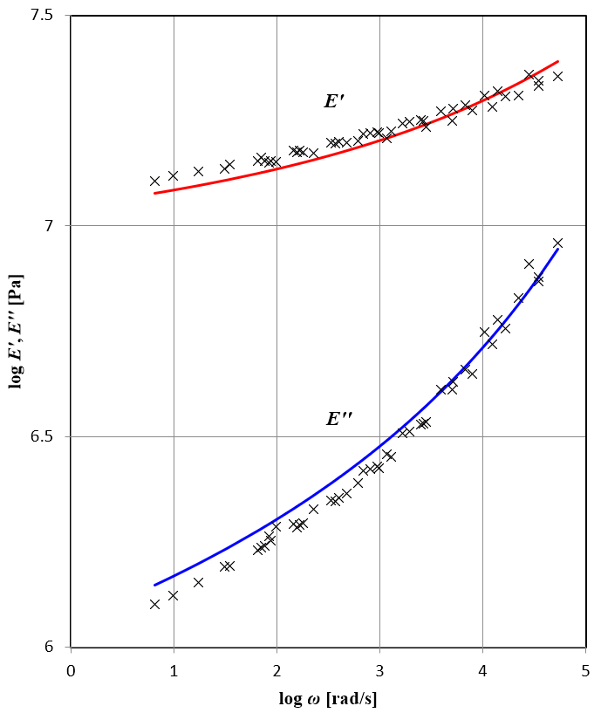

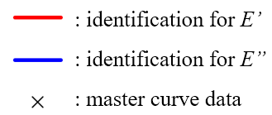

Figure 9. Curve fitting to master curve data by fractional derivative model (N = 1)
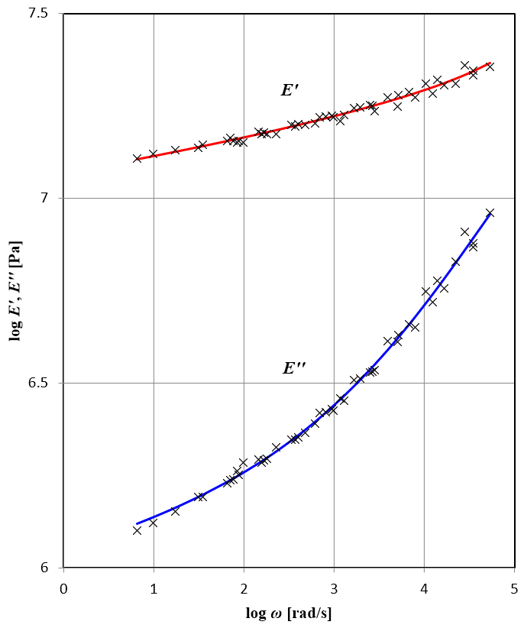

Figure 10. Curve fitting to master curve data by fractional derivative model (N = 2)

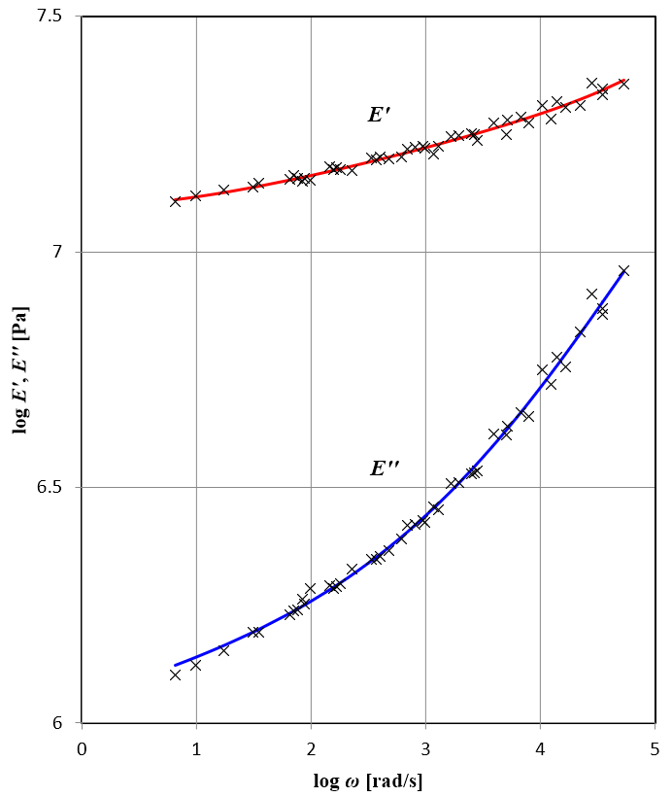

Figure 11. Curve fitting to master curve data by fractional derivative model (N = 3)
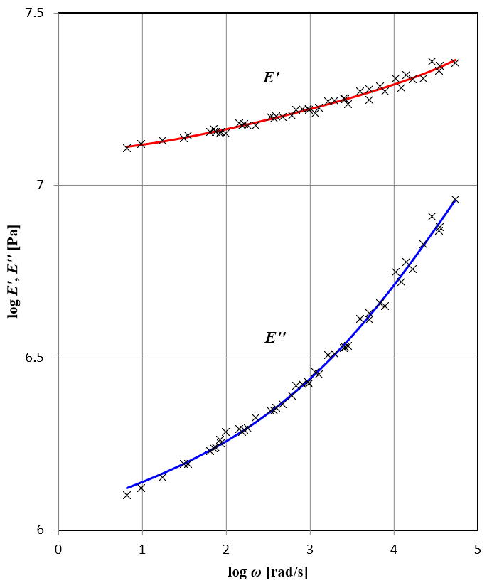

Figure 12. Curve fitting to master curve data by fractional derivative model (N = 4)
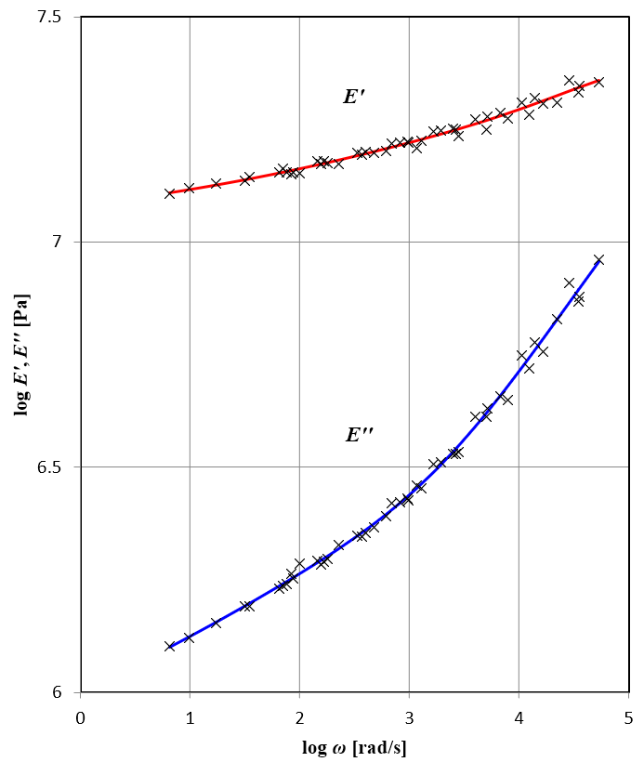

Figure 13. Curve fitting to master curve data by fractional derivative model (N = 5)
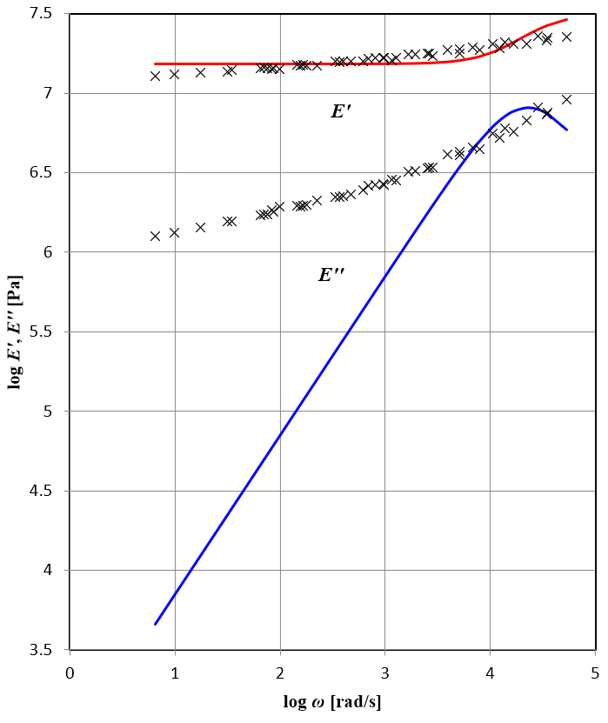

Figure 14. Curve fitting to master curve data by standard spring-dashpot model (N = 1)
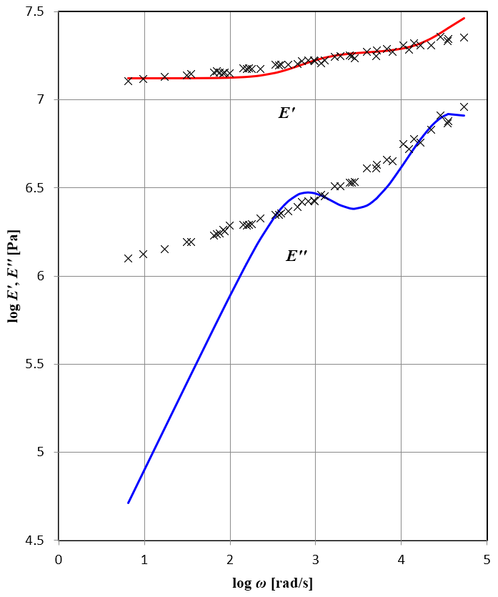

Figure 15. Curve fitting to master curve data by standard spring-dashpot model (N = 2)
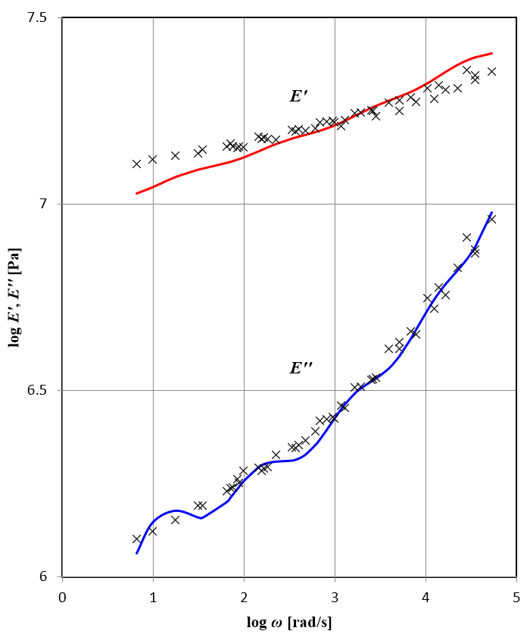

Figure 16. Curve fitting to master curve data by standard spring-dashpot model (N = 5)
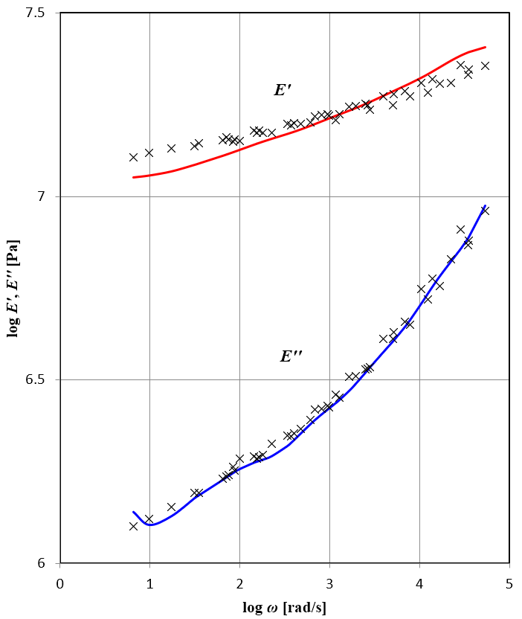

Figure 17. Curve fitting to master curve data by standard spring-dashpot model (N = 7)
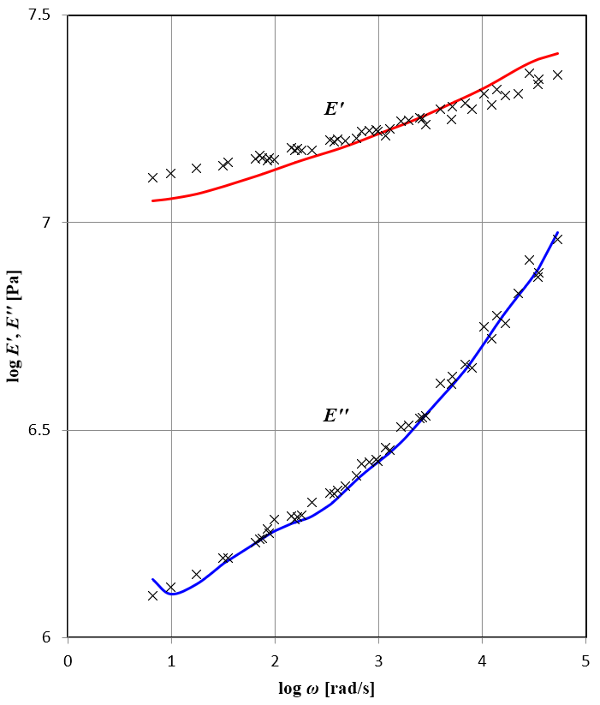

Figure 18. Curve fitting to master curve data by standard spring-dashpot model (N = 10)
18 correspond to the case of N = 2, 5, 7 and 10, respectively.
From these results even if by taking 10 set of the models the estimated curve cannot fit the experimental moduli well as the cases of the identifications by assuming the fractional derivative model N = 2. It can be observed from these results that the performance in identification of the spring-dashpot model is not good even if the number of set is increased more than N = 7.
- Conclusions
In the present study, the vibration tests for a rubber material are carried out, and the master curve is obtained numerically by applying the W.L.F. equation. The fractional derivative model and the standard spring-dashpot model are assumed for the complex module of the material, and the parameters of the two models are identified numerically. Finally, the applicability of the fractional derivative models is discussed by comparing the numerical results by the spring-dashpot models, and thus it can be concluded that the fractional derivative model has a better performance in identification of the master curve of complex modulus of a rubber material rather than the spring-dashpot model.
Reference
[1] Jones D. I. G, Handbook of Viscoelastic Vibration Damping, Wiley; 2001.
[2] Shimizu N, Dynamic Characteristics of a Viscoelastic Oscillator (in Japanese), Transaction of JSME (Ser. C), 61-583; 1995, pp.902-906.
[3] Shimizu N, Iijima M, Fractional Differential Model of Viscoelastic Material (in Japanese), Transaction of JSME (Ser. C), 62-604; 1996, pp.4447-4451.
[4] Nasuno H, Shimizu N, Yasuno T, Geometrical Nonlinear Statical and Dynamical Models of Fractional Derivative Viscoelastic Body (in Japanese), Transaction of JSME (Ser. C), 72-716; 2006, pp.1041-1048.
[5] Fukunaga M, Shimizu N, Nonlinear Fractional Derivative Models of Viscoelastic Impact Dynamics Based on Entropy Elasticity and Generalized Maxwell Law, Journal of Computational and Nonlinear Dynamics, 6, April; 2011, pp.021005
[6] Narita D, Yoshida M, Ohta Y, Yamagishi T, The Effect of Strain Amplitude on the Analytical Model for Stiffness of Viscoelastic Materials, Proceeding of Dynamics and Design Conference 2016 of JSME; 2016.

